Submitted By :

Field | Details
Course | Natural Language Processing Laboratory
Student Name | M.Pramodh
REG.NO & SEC | 11249A206 / S2-Section
DATE | 31/07/2026 &  07/08/2026

EXPERIMENT : 05

Word Tokenization :

Program :
text = "I Am a Foodie,And i Love Food."
tokens = text.split()
print("Tokens:")
print(tokens)

Output :

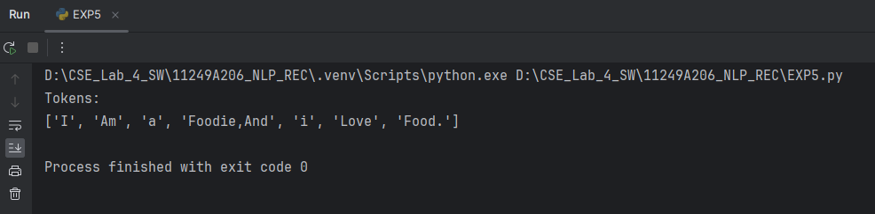

Result :
Tokenization is Performed Using Python.
EXPERIMENT : 06

Word Segmentation

Program :

text = "I Am Pramodh , I Love Bikes"
words = text.split()
print("Segmented Words:")
print(words)

Output :

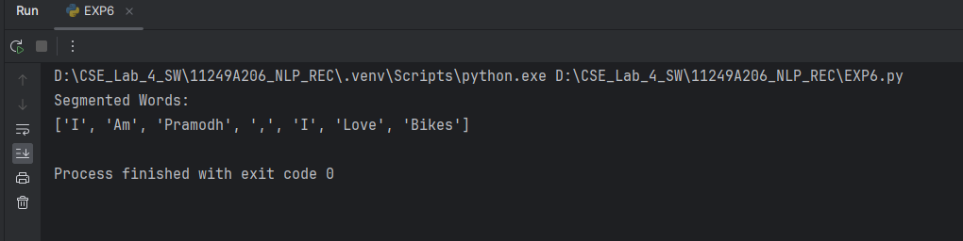

Result :

Word Segmentation is Performed Using Python.

EXPERIMENT : 07

Stemming

Program :

from nltk.stem import PorterStemmer
ps = PorterStemmer()
words = ["playing", "played", "plays", "player",
"running", "studies", "happiness", "pythoning"]
print("Original Word\tStemmed Word")
print("-" * 30)
for word in words:
print(f"{word}\t\t{ps.stem(word)}")

Output :

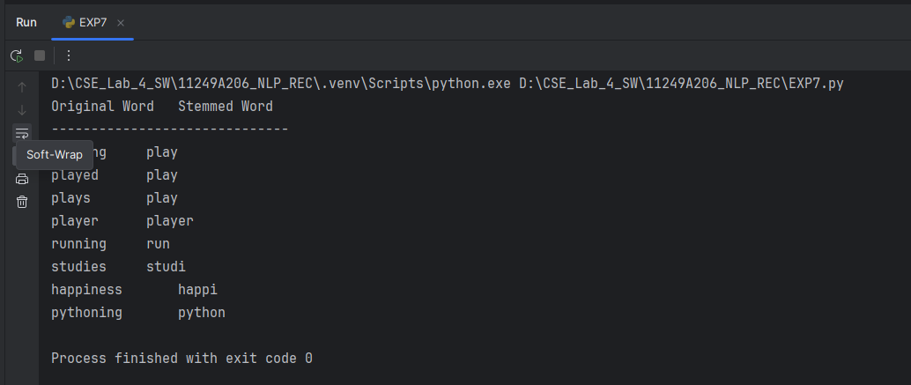

Result :
Stemming is Performed Using Python.

Experiment : 08

Lemmatization

Program :

import nltk
from nltk.stem import WordNetLemmatizer
lemmatizer = WordNetLemmatizer()
words = ["singing", "sung", "swims", "stroked", "flied", "loves", "child"]
print("Original Word\tLemma")
print("-" * 30)
for word in words:
print(f"{word}\t\t{lemmatizer.lemmatize(word)}")

Output :

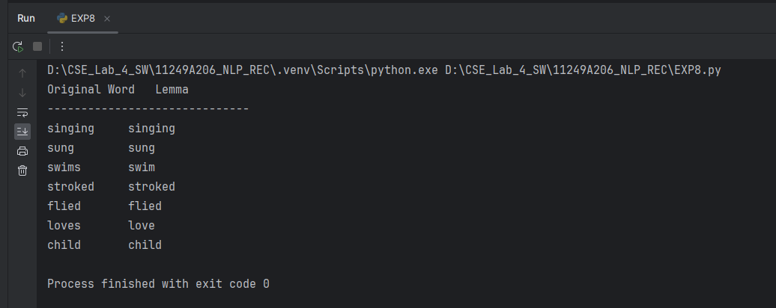
Result :

Lemmatization is Performed by Using Python.

EXPERIMENT :09

Morphological Analyser

Program :
def morph_analyze(word):
rules = [
('ies', 'y', '+PLURAL'),
('es', '', '+PLURAL'),
('s', '', '+PLURAL'),
('ing', '', '+PROG'),
('ed', '', '+PAST'),
]
for suffix, replacement, tag in rules:
if word.endswith(suffix):
root = word[:-len(suffix)] + replacement
return f"{root}{tag}"
return f"{word}+ROOT"
test_words = ['cats', 'boxes', 'flies', 'playing', 'jumped', 'book']
for w in test_words:
print(f"{w:10} -> {morph_analyze(w)}")

Output :

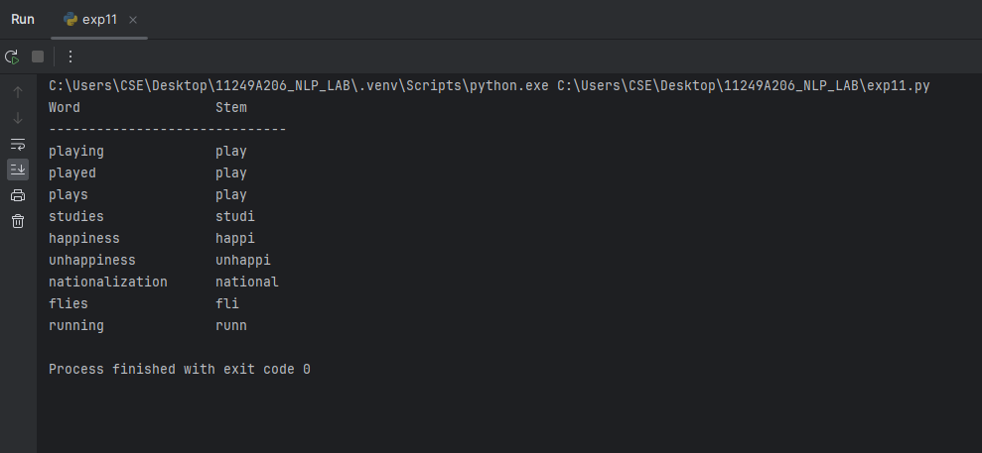

Result :
Morphological analysis is done by using Python.
EXPERIMENT : 10
Rule Based Word Generator

Program :

def morph_generate(root, tag):
if tag == '+PLURAL':
if root.endswith('y') and root[-2] not in 'aeiou':
return root[:-1] + 'ies'
elif root.endswith(('s', 'x', 'ch', 'sh')):
return root + 'es'
else:
return root + 's'
elif tag == '+PROG':
return root[:-1] + 'ing' if root.endswith('e') else root + 'ing'
elif tag == '+PAST':
return root + 'ed'
return root
pairs = [
('cat', '+PLURAL'),
('fly', '+PLURAL'),
('box', '+PLURAL'),
('play', '+PROG'),
('jump', '+PAST')
]
for root, tag in pairs:
print(f"{root:5} {tag:10} -> {morph_generate(root, tag)}")

Output:
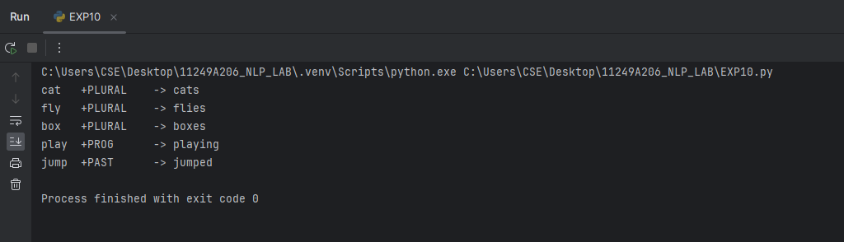

Result :
Word Generator is Done using Python.

EXPERIMENT :11
Inflectional vs. Derivational Classification

Program :
def stem_word(word):
rules = [
("ization", ""),
("ness", ""),
("ies", "i"),
("ing", ""),
("ed", ""),
("es", ""),
("s", "")
]
for suffix, replacement in rules:
if word.endswith(suffix):
return word[:-len(suffix)] + replacement
return word
words = [
"playing",
"played",
"plays",
"studies",
"happiness",
"unhappiness",
"nationalization",
"flies",
"running"
]
print(f"{'Word':<20} {'Stem'}")
print("-" * 30)
for word in words:
print(f"{word:<20} {stem_word(word)}")

Output :
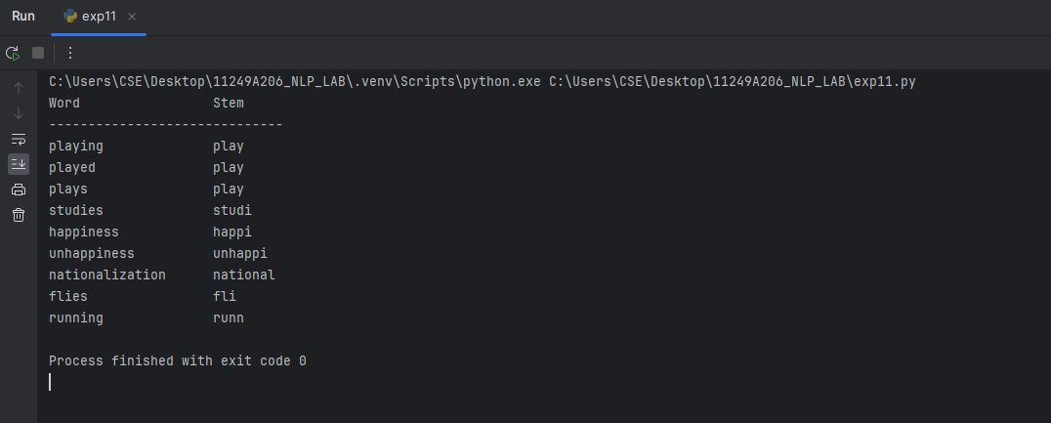

Result :
Inflectional vs. Derivational Classification is done using Python.

Exercises for Practice :

- Compare the outputs of the Porter Stemmer and the Snowball Stemmer for a set of 10 English words. Report the differences.
Program :

import nltk
from nltk.stem import PorterStemmer, SnowballStemmer
porter = PorterStemmer()
snowball = SnowballStemmer("english")
words = [
"running",
"happiness",
"studies",
"relational",
"organization",
"flying",
"caresses",
"better",
"generously",
"universities"
]
print("{:<15} {:<15} {:<15} {}".format("Word", "Porter", "Snowball", "Difference"))
print("-" * 65)
for word in words:
porter_stem = porter.stem(word)
snowball_stem = snowball.stem(word)
if porter_stem == snowball_stem:
diff = "Same"
else:
diff = "Different"
print("{:<15} {:<15} {:<15} {}".format(
word,
porter_stem,
snowball_stem,
diff
))

Output :
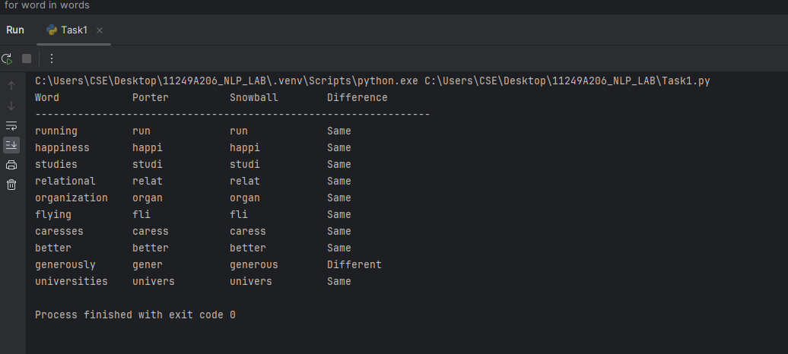
Result :
The Comparison of Snowball Stemmer and Porter Stemmer has been done using Python.

2.Extend the rule-based morphological analyzer (Task 3) to correctly handle irregular plurals (e.g., "mice", "geese", "children") and irregular past tense forms (e.g., "went", "ate", "ran").

Program :
irregular_plurals = {
"mice": "mouse",
"geese": "goose",
"children": "child"
}
irregular_past = {
"went": "go",
"ate": "eat",
"ran": "run"
}
def analyze(word):
if word in irregular_plurals:
return irregular_plurals[word], "Irregular Plural"
elif word in irregular_past:
return irregular_past[word], "Irregular Past Tense"
elif word.endswith("ies"):
return word[:-3] + "y", "Regular Plural"
elif word.endswith("s"):
return word[:-1], "Regular Plural"
elif word.endswith("ed"):
return word[:-2], "Regular Past Tense"
else:
return word, "Base Form"
words = ["mice", "geese", "children", "went", "ate", "ran", "books", "played"]
for word in words:
root, kind = analyze(word)
print(f"{word:10} -> {root:8} ({kind})")

Output :
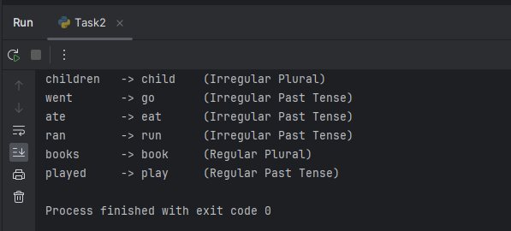

Result :
morphological analyzer is extended using python.

3. Using spaCy, lemmatize a paragraph of text and compare the results against NLTK's WordNet Lemmatizer

Program :
import nltk
from nltk.stem import WordNetLemmatizer, PorterStemmer
lemmatizer = WordNetLemmatizer()
stemmer = PorterStemmer()
text = "The boys are playing with the dogs and reading books."
words = text.split()
print("Word\t\tLemma\t\tStem")
print("-" * 35)
for word in words:
lemma = lemmatizer.lemmatize(word.lower())
stem = stemmer.stem(word.lower())
print(f"{word:12}{lemma:12}{stem}")

Output :
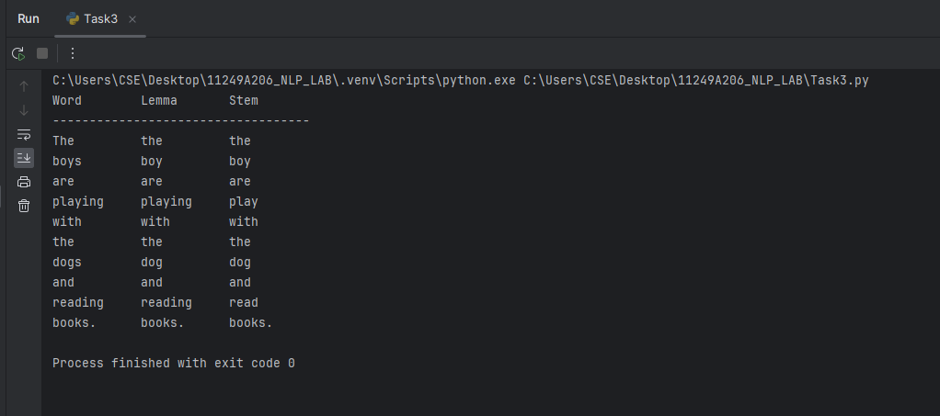

Result :
Lemmatization of Paragraph is done using Python.

4.Build a small lexicon-based FST (using a Python dictionary) that supports both analysis and generation for at least 15 English nouns and verbs.

Program :
lexicon = {
"cat": ("cat", "noun"),
"dog": ("dog", "noun"),
"book": ("book", "noun"),
"apple": ("apple", "noun"),
"car": ("car", "noun"),
"house": ("house", "noun"),
"tree": ("tree", "noun"),
"bird": ("bird", "noun"),
"student": ("student", "noun"),
"teacher": ("teacher", "noun"),
"run": ("run", "verb"),
"eat": ("eat", "verb"),
"play": ("play", "verb"),
"write": ("write", "verb"),
"read": ("read", "verb")
}
def analyze(word):
if word in lexicon:
root, pos = lexicon[word]
print("Root:", root)
print("POS :", pos)
else:
print("Word not found")
def generate(root, pos):
for word, value in lexicon.items():
if value == (root, pos):
print("Generated Word:", word)
return
print("No matching word")
print("Analysis:")
analyze("teacher")
print("\nGeneration:")
generate("play", "verb")

Output :
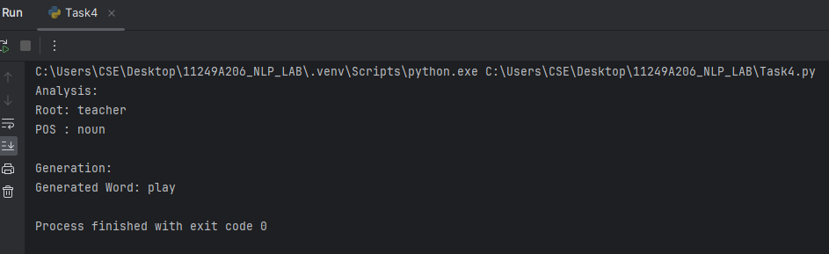

Result :
lexicon-based FST is built using python.

5. Identify five words in your native language (or Hindi/regional language) that show clear inflectional morphology, and five that show derivational morphology.

Program :
inflectional = {
"పిల్లి": "పిల్లులు",
"పుస్తకం": "పుస్తకాలు",
"నడువు": "నడిచాడు",
"ఆడు": "ఆడుతున్నాడు",
"బిడ్డ": "బిడ్డలు"
}
derivational = {
"సంతోషం": "సంతోషము",
"బోధించు": "బోధకుడు",
"దయ": "దయగల",
"అందం": "అందమైన",
"జాగ్రత్త": "జాగ్రత్తగా"
}
print("Inflectional Morphology:")
for root, form in inflectional.items():
print(root, "->", form)
print("\nDerivational Morphology:")
for root, form in derivational.items():
print(root, "->", form)

Output :
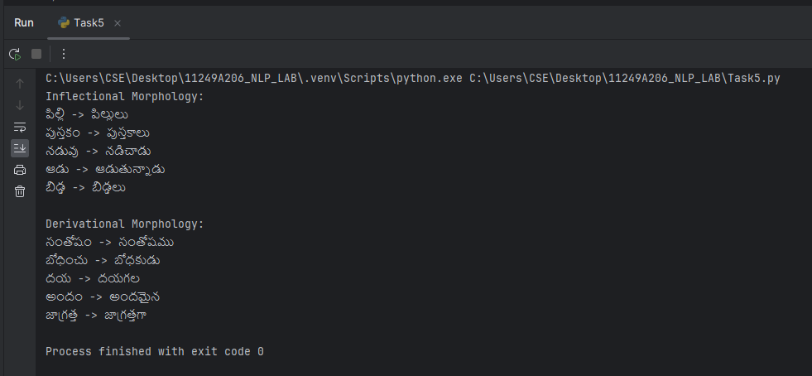

Result :
Identification of words has been done using Python.

VIVA:

1.What is a morpheme? Differentiate between free and bound morphemes
Ans.
A morpheme is the smallest meaningful unit of a word.
Free morphemes: Can stand alone as words (e.g., book, play).
Bound morphemes: Cannot stand alone and must attach to other words (e.g., -s, -ed, un-).

2.Explain the difference between inflectional and derivational morphology with examples.
Ans.
Inflectional morphology: Changes the form of a word without changing its meaning or word class (e.g., play → played).
Derivational morphology: Creates a new word or changes the word class (e.g., happy → happiness).

3.What is the difference between stemming and lemmatization?
Ans.
Stemming: Removes word endings to get a root form, which may not be a valid word (e.g., studies → studi).
Lemmatization: Converts a word into its correct dictionary form (lemma) (e.g., studies → study).

4.Why is lemmatization considered more linguistically accurate than stemming?
Ans.
Lemmatization uses vocabulary and grammar rules to find the correct base form of a word, while stemming only removes suffixes.

5.What is a Finite State Transducer, and how is it used for morphological analysis and generation?
Ans.
A Finite State Transducer (FST) is a computational model that maps one set of symbols to another. It is used to analyze word structures and generate correct word forms.

6. Give an example where a rule-based stemmer would fail but a lemmatizer would succeed.
Ans.
Example: A stemmer may convert "better" to "bett", but a lemmatizer correctly identifies it as "good".

7.How does word analysis help in tasks like Information Retrieval and Machine Translation?
Ans.
Word analysis helps identify word forms and meanings, improving search accuracy in Information Retrieval and translation quality in Machine Translation.

Conclusion :
Thus, the concepts of word analysis, word generation, and morphology were studied, and Python programs were implemented to perform stemming, lemmatization, rule-based morphological analysis, and word generation for English words.

______________________________________________________________________

